Cover Letter for PHA Policies: HOTMA and NSPIRE Implementation

The following explains the implementation timeline for PHA policies related to the Housing Opportunity through Modernization Act of 2016 (HOTMA) and the National Standards for the Physical Inspection of Real Estate (NSPIRE).

HOTMA SECTIONS 102 AND 104 CHANGES
- On July 29, 2016, the Housing Opportunity Through Modernization Act of 2016 (HOTMA) was signed into law. HOTMA made numerous changes to statutes governing HUD programs, including sections of the United States Housing Act of 1937. Title I of HOTMA contains 14 different sections that impact the public housing and Section 8 programs.
- HUD published a final rule on February 14, 2023, revising regulations related to income and assets (Sections 102 and 104 of HOTMA) for HOTMA. While the new income and asset regulations were effective January 1, 2024, HUD has instructed PHAs to select a compliance date for these sections no later than January 1, 2025.
- However, PHAs are currently unable to select a compliance date for Section 102 and 104 of HOTMA. HOTMA compliance depends on transitioning HUD’s IMS/PIC system (which is unable to accept HOTMA-compliant certifications) to HUD’s new Housing Information Portal (HIP) system. PHAs cannot transition to HOTMA until HIP is in place, HOTMA-compliant, and accessible. In a June 17, 2024, letter to executive directors, HUD delayed the transition from IMS/PIC to HIP and has not yet provided a timeline for HIP implementation.
  - Note that in FAQs dated 2/22/24, HUD determined that certain HOTMA changes are not dependent on transitioning to the HIP system, and PHAs may implement them immediately. This is optional.
- Although HOTMA will not be implemented by the PHA until an unknown date in the future, the PHA is required to update both the ACOP and administrative plan by a specific date. PHAs are required to update PHA plans and policies based on the PHA’s fiscal year start date. PHAs must have their plan updated the earliest of:
  - 75 days prior to the start of their fiscal year (beginning with 7/1/24 PHAs);
  - 75 days prior to their compliance date (if the PHA selects a compliance date prior to the start of their fiscal year); or
  - October 18, 2024 (for PHAs with fiscal year start dates of 1/1/25 and 4/1/25).
- This means that the PHA’s policies will likely be completed and approved well ahead of when the PHA actually implements HOTMA. During the transition period between when the PHA adopts its new HOTMA-compliant policies and the date the PHA fully implements HOTMA, the PHA will have two policies in place – one that is updated for HOTMA and their pre-HOTMA policy (which may include those changes identified by HUD in the 2/22/24 FAQs). The PHA will adopt but will not follow their HOTMA policy during this transition period. The PHA will instead continue to follow their current policies until the PHA-selected implementation date for HOTMA. Pre-HOTMA policies will remain fully effective during the transition period.

HOTMA VOUCHER FINAL RULE CHANGES
- The Final Rule implementing streamlining changes to the HCV and PBV programs was published on May 7, 2024, and codified certain provisions in Sections 101, 105, 106, and 112 of HOTMA, as well as incorporating some changes from the NSPIRE final rule. The rule is known as the “HOTMA voucher final rule.” The effective date of the HOTMA voucher final rule was June 6, 2024.
- While the compliance date for certain provisions of the rule is the same as the effective date, the compliance date for other provisions is not until 90 days, 180 days, or one year after the effective date.
- Further, many new changes to the regulations described in the HOTMA voucher final rule require changes to the PHA’s administrative plan. PHAs must make all revisions needed to bring existing policies into compliance with the final rule no later than June 6, 2025 (one year after the effective date of the rule).
- However, if a PHA wishes to use program flexibilities requiring adoption of new local policies not already present in the PHA’s administrative plan, the PHA must add those policies to the administrative plan prior to using those program flexibilities.
- Further, the delayed compliance date for policies of June 6, 2025, does not authorize delayed compliance with the provisions of the rule. PHAs that choose not to bring their policies into compliance with the rule until June 6, 2025, must still implement each provision on its compliance date.
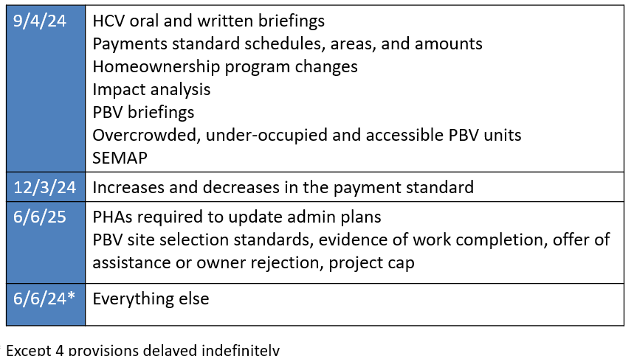

NSPIRE AND HQS (HCV Program Only)
- The PHA must determine that the rental unit selected by the family is in safe and habitable condition at certain times prescribed by the regulations. The current applicable inspection standard for the HCV and PBV programs is Housing Quality Standards (HQS).
- On May 11, 2023, HUD published a final rule implementing the National Standards for the Physical Inspection of Real Estate (NSPIRE final rule), a new approach to defining and assessing housing quality across multiple HUD programs. 24 CFR 5.703 describes the NSPIRE standards, including variations for the HCV and PBV programs. Notice PIH 2023-28 finalized the administrative procedures for NSPIRE as they pertain specifically to the HCV and PBV programs. Collectively, this is known as “NSPIRE-V.”
- One June 14, 2024, HUD moved the compliance date for NSPIRE-V back from October 1, 2024 to no later than October 1, 2025, at which point the HQS inspection standard will sunset. PHAs may, however, implement NSPIRE-V prior to October 1, 2025, provided they follow requirements listed in Notice PIH 2023-28.
- However, even once the HQS inspection standard has sunset, the regulations at 24 CFR Part 982 and 983 governing the HCV and PBV programs will continue to use the terms HQS and housing quality standards rather than NSPIRE. This is because, the definition of housing quality standards (HQS) at 24 CFR 982.4 means the minimum quality standards developed by HUD in accordance with 24 CFR 5.703 for the HCV program, including any variations approved by HUD for the PHA. As such, the model policy uses the term housing quality standards whenever applicable regulations use this term.

